**Lab 6 Documentation**

**Design Idea:** using ultrasonic sensor to measure the distance and then using motor to control the distance via close-loop control. The LCD Display will show the distance on the screen in centimeters. And when it reaches both close and far ends and midpoint, the LCD display will show the location status information of the board instead of the distance in cm.

The belt has a piece of paper board attached for ultrasonic radar measuring. Larger the board, better the measurement. But the larger board also has larger inertia which requires the motor generates larger torque.

**Control methodology:** with the measurement read from ultrasonic radar, I designed a close loop control via using the continuous measurement. Once the target distance is reached, the motor will stop moving the belt.

The circuit has a semi-conductor chip to control the rotating direction of the motor (L239D). The chip is a half-H Driver designed to provide bidirectional drive currents of up to 600 mA at voltages from 4.5 V to 36 V. The chip also has an internal protection diode thus the user doesn’t need to add an external diode between the chip and the motor.

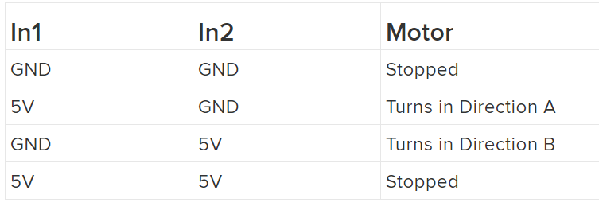

Control logic of L293D

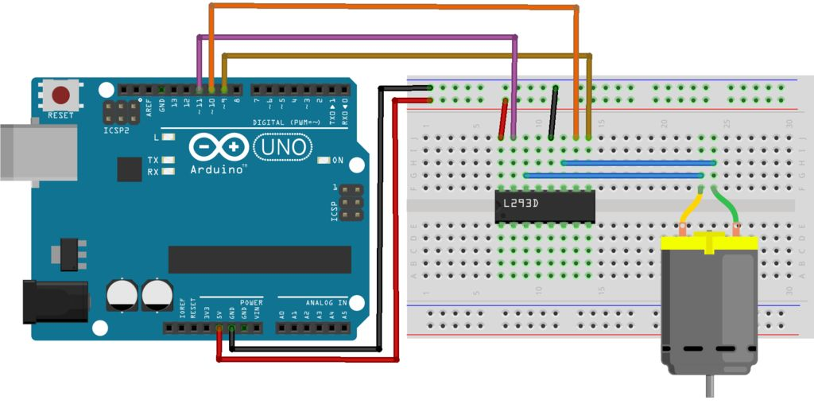

L293D circuit to control motor direction (moving forward and backward)

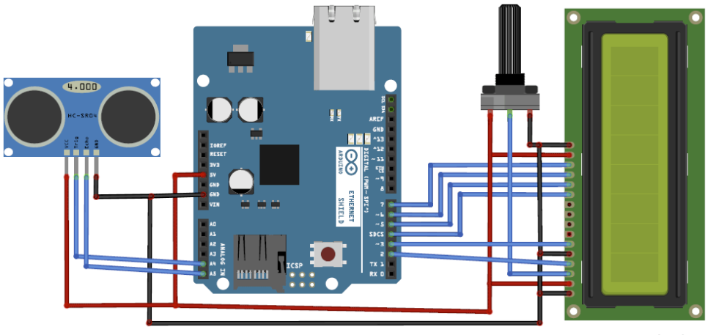

Ultrasonic sensor to measure distance

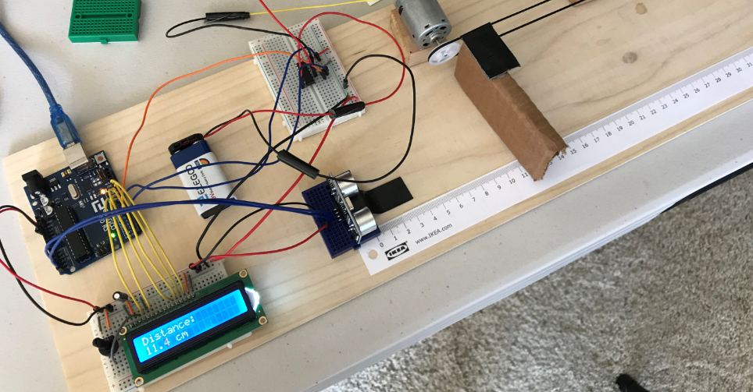

Entire setup

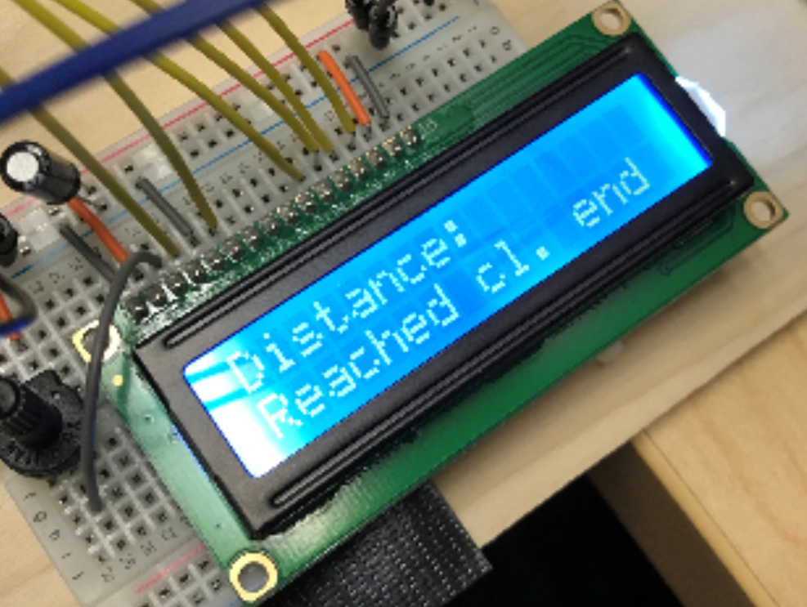

When it reaches to the closer end

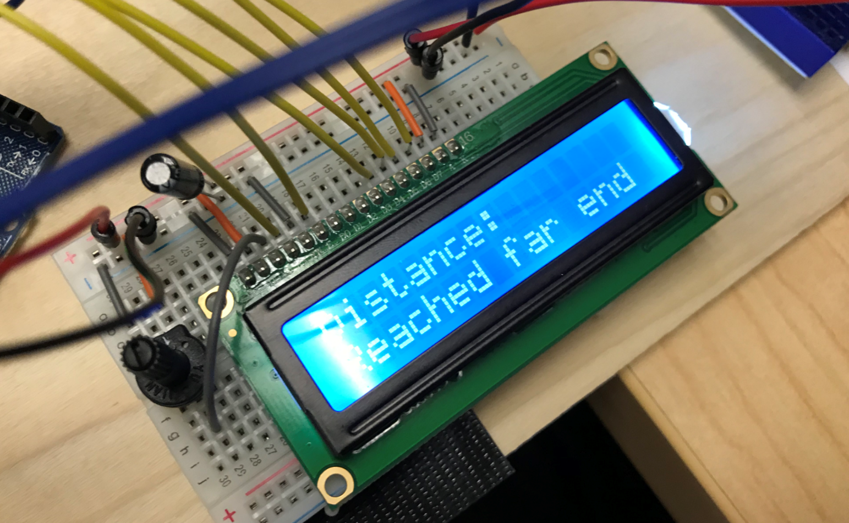

When it reaches to the far end

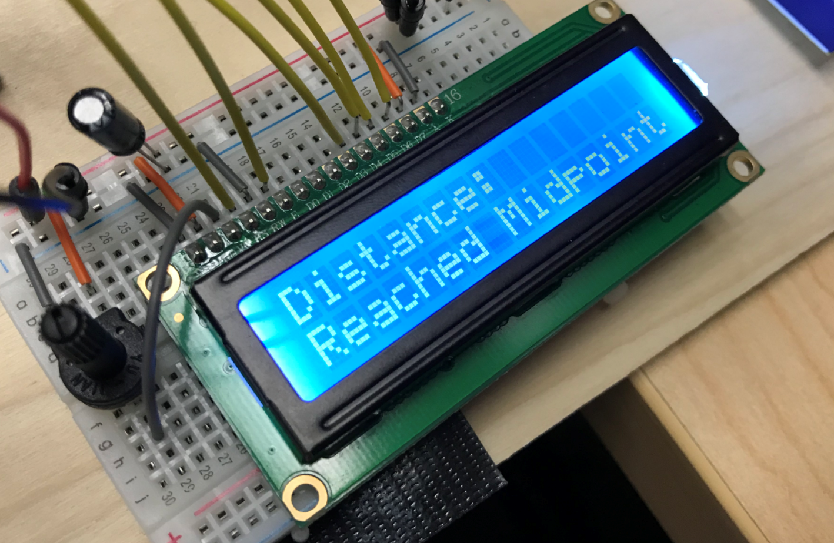

When it reaches to the midpoint

**Code**

/*  lab6 Zhibo Wang

Control based on Sensor Feedbacks

 */

#include <LiquidCrystal.h>

LiquidCrystal lcd(8, 9, 10, 11, 12, 13);

const int echo = 18;

const int trigger = 19;

float time = 0;

float distance = 0;

const int enable2 = 3;

const int in3 = 5;

const int in4 = 6;

float targetDistance;

void setup()

{

    // opens serial port, sets data rate to 9600 bps

    Serial.begin(9600);

    pinMode(trigger, OUTPUT);

    pinMode(echo, INPUT);

    pinMode(enable2, OUTPUT);

    pinMode(in3, OUTPUT);

    pinMode(in4, OUTPUT);

    // set up the LCD's number of columns and rows:

    lcd.begin(16, 2);

    lcd.print("Ultrasonic");

    // set the cursor to (column 0, line 1)

    // line 1 is the second row, since counting begins with 0

    lcd.setCursor(0, 1);

    lcd.print("Distance Control");

    lcd.clear();

    lcd.print("System Initializing");

    delay(2000);

    targetDistance = 15;

}

void loop()

{

    lcd.clear();

    digitalWrite(trigger, LOW);

    delayMicroseconds(2);

    digitalWrite(trigger, HIGH);

    delayMicroseconds(10);

    digitalWrite(trigger, LOW);

    delayMicroseconds(2);

    time = pulseIn(echo, HIGH);

    distance = time * 330 / 20000;

    lcd.clear();

    lcd.print("Distance: ");

    lcd.setCursor(0, 1);

    if (distance < 11)

    {

        lcd.print("Reached cl. end");

    }

    else if (distance > 20)

    {

        lcd.print("Reached far end");

    }

    else if (16 < distance && distance < 17)

    {

        lcd.print("Reached Midpoint");

    }

    else if (distance > 11 && distance < 21)

    {

        lcd.print(distance, 1);

        lcd.print(" cm");

    }

    delay(1500);

    // // -> 20cm (CW)

    // analogWrite(enable2, 255);

    // digitalWrite(in3, HIGH);

    // digitalWrite(in4, LOW);

    // delay(3000);

    // // 10cm <- (CCW)

    // analogWrite(enable2, 255);

    // digitalWrite(in3, LOW);

    // digitalWrite(in4, HIGH);

    // delay(3000);

    targetDistance = distanceControl(targetDistance, distance);

}

float distanceControl(int targetDistance, float distance)

{

    if (targetDistance > distance)

    {

        analogWrite(enable2, 255);

        digitalWrite(in3, LOW);

        digitalWrite(in4, HIGH);

    }

    else if (targetDistance < distance)

    {

        analogWrite(enable2, 255);

        digitalWrite(in3, HIGH);

        digitalWrite(in4, LOW);

    }

    digitalWrite(trigger, LOW);

    delayMicroseconds(2);

    digitalWrite(trigger, HIGH);

    delayMicroseconds(10);

    digitalWrite(trigger, LOW);

    delayMicroseconds(2);

    time = pulseIn(echo, HIGH);

    distance = time * 330 / 20000;

    if (targetDistance - 0.5 < distance || distance < targetDistance + 0.5)

    {

        targetDistance = distance;

    }

    return targetDistance;

}